**Analog Design Lecture Assignment #1**

**Name: Karim Mahmoud Kamal Mohamed**

**Section: 16**

**AUC ID: V23010174**

**Supervisor: Dr. Mamdouh Abdelmejeed**

**"Who Says Elephants Can't Dance?"**

**In the early 1990s, IBM was facing a significant crisis due to various internal and external challenges:**

1. **IBM's inability to adapt to the rapidly changing technology landscape. The company had traditionally focused on mainframe computers, which were losing popularity as personal computers and client-server systems gained prominence. IBM's failure to recognize and respond to these shifts in the industry resulted in a decline in market share and financial performance.**
2. **IBM's complex organizational structure and culture. The company had become overly centralized, with decision-making processes being slow and cumbersome. This hindered innovation and agility, making it difficult for IBM to keep up with its more nimble competitors.**
3. **IBM had become too focused on selling hardware and had neglected the importance of software and services. As technology evolved, customers were increasingly seeking integrated solutions rather than standalone products.**

**To address these challenges and lead IBM's recovery, Lou Gerstner implemented several key strategies:**

1. **IBM shifted in focus from hardware to software and services. Gerstner recognized the importance of providing integrated solutions to customers and invested heavily in building a robust software portfolio. This strategic shift helped IBM diversify its revenue streams and better meet customer needs.**
2. **Gerstner also prioritized customer-centricity and emphasized the importance of understanding customer requirements. He encouraged a culture of listening to customers and responding to their needs, which helped IBM regain customer trust and loyalty.**
3. **Gerstner implemented a significant organizational transformation within IBM. He streamlined the company's complex structure, reducing bureaucracy and empowering employees to make decisions more efficiently. This allowed for greater innovation and responsiveness to market changes.**
4. **Another crucial aspect of IBM's recovery under Gerstner was a focus on partnerships and alliances. Recognizing that no single company could excel in all areas, Gerstner forged strategic partnerships with other technology companies. These alliances helped IBM expand its offerings and access new markets, strengthening its competitive position.**

**Overall, Lou Gerstner's leadership played a pivotal role in IBM's successful turnaround. By shifting the company's focus, transforming its organizational structure, prioritizing customer-centricity, and forming strategic partnerships, Gerstner was able to guide IBM out of crisis and restore its position as a leading technology company.**

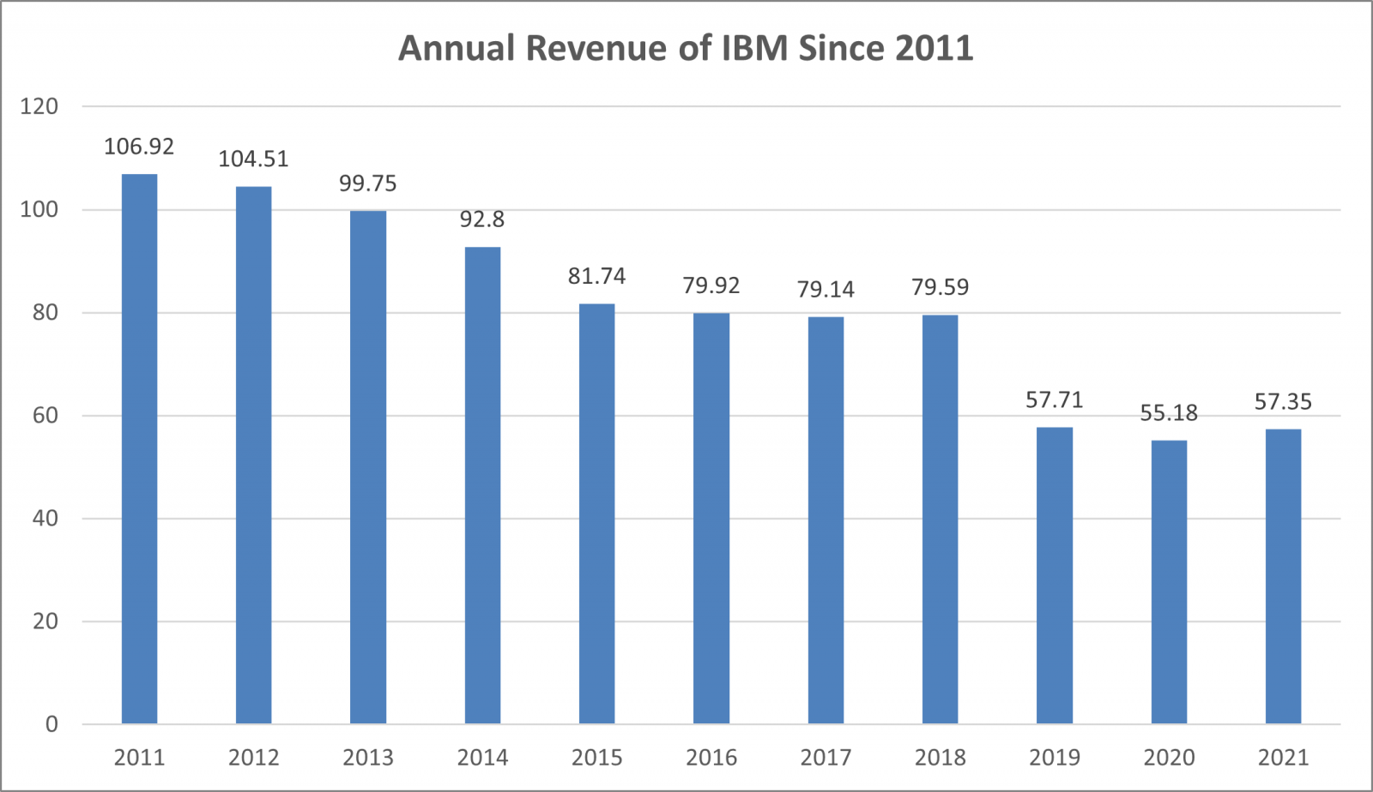

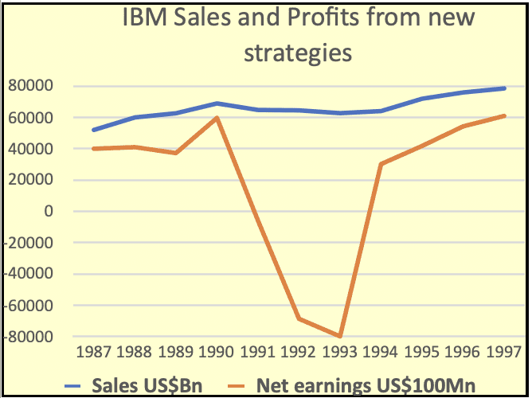

**Top 3 Authoritative Reference Publications or Domain Names Used:**

**1. "Who Said Elephants Can't Dance?" by Louis V. Gerstner Jr.**

**2. IBM official website (www.ibm.com)**

**3. Harvard Business Review (hbr.org)**